Swanson Upcoming Events / Reminders:

Yorktown Pyramid Concert - November 18th @ 7pm

Next Concert - December 10th, @7pm Swanson Auditorium

Williamsburg Upcoming Events / Reminders:

Yorktown Pyramid Concert - November 18th @ 7pm

Next Concert – December 10th, @7pm WMS Auditorium

Yorktown Upcoming Events /Reminders:

Yorktown Pyramid Concert - November 18th @ 7pm

Next Concert – December 17th, @ 7pm YHS Auditorium

Special thanks to the following for their continuous support

Dr. Francisco Durán, Superintendent

Dr. Pam Farrell, Supervisor, APS Arts Education

Kelly Breedlove, Assistant Supervisor, APS Arts Education

Dr. Kevin Clark, Principal, Yorktown HS

Bridget Loft, Principal, Swanson MS

Bryan Boykin, Principal, Williamsburg MS

Michael Krulfeld, Activities Director, Yorktown HS

Yorktown High School Custodial Staff

Yorktown Choral Boosters

Fall Choir Concert

Swanson Middle School

Williamsburg Middle School

Yorktown High School

Directors:

Josie Walker, Emily McTavish

and Jocelyn Mullins

Pianists: Barbara Schelstrate &

Molly Vu

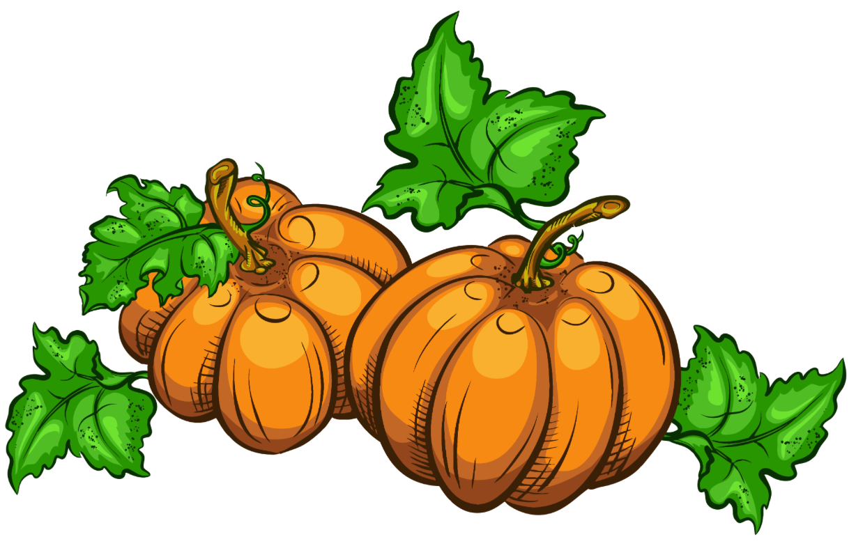

Tuesday October 22nd, 2024 @ 7:00pm

Yorktown High School Auditorium

YHS Concert Choir

Sesere Eeye … traditional song from the Torres Strait Islands

Loch Lomond … arr. by Earlene Rentz

Williamsburg MS Concert Choir

Lachend … Words & Music by Cesar Bresgen, Arr. Douglas Beam

Spooky Scary Skeleton … Words & Music by Andrew Gold,

Arr. Roger Emerson

Dancers: Annabelle Headd, Regan Healy, Sydney Hilburn,

Penny Kitchen, Kyra Pal, Emmie Reiss,

Jacqueline Sandridge, Gwendolyn Young

YHS Treble Choir

Songbird … Words & Music by Sarah Quartel

Swanson MS Beginning Chorus

The Moon … Words & Music by Andy Beck

Cirandeiro … Brazilian Folk Song, Arr. by Brad Green

Swanson Intermediate Chorus

Winter Waltz … Music by Vicki Tucker Courtney

Some One … Music by by Cristi Cary Miller

YHS Chamber Choir

Song for the Mira … Words & Music by Allister MacGillivray, arr. by

Stuart Calvert

Soloists: Sean Scott, Madeline Ladewig, Torsha Basistha,

Rose Spence, Paul Gulick, & Katie Rash

Jabula Jesu … Zulu Folk Song arr. by Stephen Hatfield

Yorktown Singers

The Seal Lullaby … by Eric Whitacre

Everyone Sang … Words by Siegfried Sassoon,

Music by Ko Matsushita

Combined Piece

I Sing Because I’m Happy … arr. by Kenneth Paden,

adapted by Rollo Dilworth



Don’t forget to donate to our bake sale and take some tasty treats home tonight.

**Please do not eat in the auditorium**.